**BCG - Guesstimate**

1. Problem Statement
2. Learning Objective
3. Prerequisites
   1. What is AdSense?
   2. How does it work?
4. Approach
   1. Ask questions
   2. High-level view
   3. Establish assumptions
   4. Estimation tree
   5. Calculate bottom-up
5. Sanity Check

**Problem Statement**

**Boston Consulting Group (BCG)** partners with leading businesses to hire talented professionals who are capable of tackling challenges with their products.

For a recent project, they have opened up many positions for Product Analysts/Managers.

You, as an aspiring **Product Analyst**, have received an interview assignment from BCG where you have to come up with a strategy to **estimate the Adsense revenue for websites.**

**Discuss what approach you would take in order to solve this problem.**

**Learning Objectives**

The sole purpose of this guesstimate is to check -

* How structured is your approach?
* How comfortable are you with estimating numbers?
* Can you do back-of-the-mind calculations and validate the numbers?

**Prerequisites**

Things that we need to know before moving ahead:

1. What is Adsense?

2. How does it work?

3. Basic terminologies: **CPC**, **CPM**, **CTR**

**What is AdSense?**

* There are many ways to monetize your website traffic, and most of them are related to advertising third-party products or services to your website visitors.
* There are many advertising programs that can help you earn money nowadays, but the most popular is Google AdSense.
* AdSense is a free-of-charge, simple way to earn money by displaying ads next to your online content.
* With AdSense, you can show relevant and engaging ads to your site visitors and even customize the look and feel of ads to match your site.



**How does it work?**

The whole process is quite simple. You create an AdSense account, insert a small code into your website’s pages and that’s all you need to start. Google will display targeted ads on your page that are either relevant to the content of your website or to users’ previous searches, based on its proprietary algorithms.



Your website visitors will start clicking those ads, and the best part is you will be paid for it**.** Google AdSense works on a **cost-per-click** and revenue-sharing basis. This means that your main task will be to provide **as many clicks to those ads as possible.**

**Basic Terminologies:**

Let us compare and see what CPC, CPM and CTR are.

## Cost per click (CPC) is an online advertising revenue model that websites use to bill advertisers based on the number of times visitors click on a display ad attached to their sites.

**How is cost per click calculated?**

## Advertisers commonly use cost per click with a set daily budget for a campaign. When the advertiser's budget is reached, the ad is automatically removed from the website's rotation for the remainder of the billing period. For example, a website with a cost-per-click rate of $.10 would bill an advertiser $100 for 1,000 click-throughs.

## 

## **How to lower Cost Per Click?**

## 

## Because advertising can become very expensive when paying by clicks, you need to have a plan to keep from paying too much per click. This means researching and creating a strategy with keywords to raise your **Quality Score**, a large measure of how your ads compete with others.

### 

### **Raising your Quality Score**

## Your Quality Score is crucial to increasing your clicks and decreasing your costs. You can improve your Quality Score by making adjustments to your:

* **Expected clickthrough rate**: You can edit the ad to make it more appealing to your targeted consumer base, highlight features and benefits, and above all, ensure your ad details match your keywords.
* **Ad relevance**: Your ad should appeal to your audience and their search intent. Look at search results for different phrases and analyze the results.
* **Landing page experience**: Landing pages should be relevant to the audience that clicks the ad. For instance, an advertisement for a widget shouldn't lead to a landing page featuring gadgets. Additionally, the speed your landing page loads should be fast enough on mobile devices and computers so that potential customers don't need to wait.

## The primary alternative is the [cost per mille](https://www.investopedia.com/terms/c/cpm.asp) (CPM) model, which charges 1,000 ad impressions—or views—of the display ad, regardless of whether or not a viewer clicks on the ad.

______________________________________________________________________

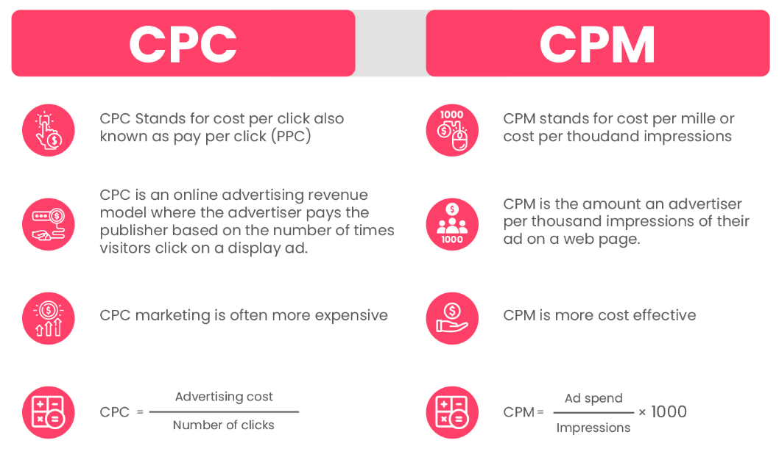

**____________________________________________________________**

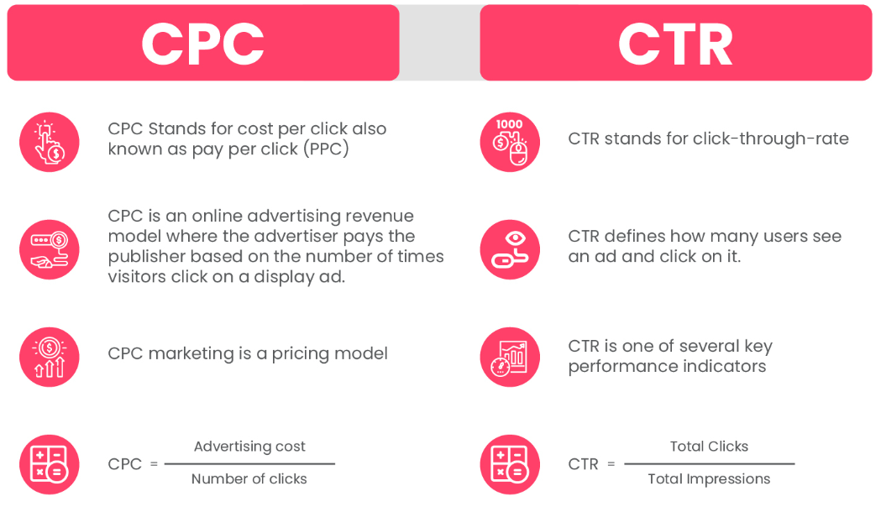

**____________________________________________________________**

**Approach**

This is the 6-step approach that we will be following while solving this estimation.

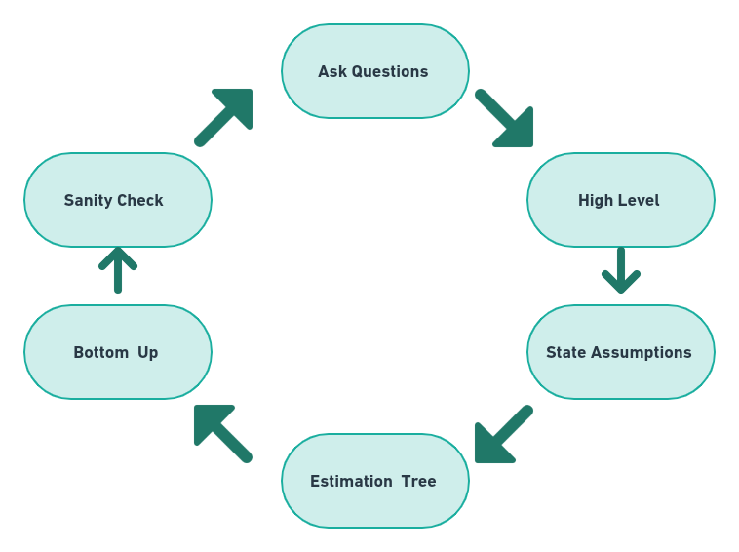

1. **Ask Questions:** When the guess estimate is thrown at you, ask questions to clarify all doubts to get a good level of understanding of the problem.
2. **High Level:** Come up with a high-level view of how to solve the problem.
3. **State Assumptions:** With whatever knowledge you have, state assumptions that will help you solve the problem.
4. **Estimation Tree:** It is nothing but a tree map with the entire flow of estimation.
5. **Bottom Up:** We will start our calculations from the bottom of the tree.
6. **Sanity Check:** Get a check to make sure everything is in place.

**Asking clarifying questions…**

______________________________________________________________________

**Q1.** AdSense is a Google advertising solution for publishers, and it is only for third-party websites, right?

**Ans:** Yes. It does not include Google properties like YouTube, etc.

______________________________________________________________________

**Q2.** The way Google AdSense works is that it enables publishers to offer ad space on their properties by allowing marketers to bid for those spaces?

**Ans:** Yes.

______________________________________________________________________

**Q3.** Okay. I know that publishers get a share of the bid, so should the estimate exclude this share?

**Ans:** No. Estimate the entire AdSense revenue, including the publisher’s share, which by the way is called the Traffic Acquisition Cost.

______________________________________________________________________

**Q4.** Should I assume this to be a one-year estimate?

**Ans:** Yes.

______________________________________________________________________

**High-level view of the estimation -**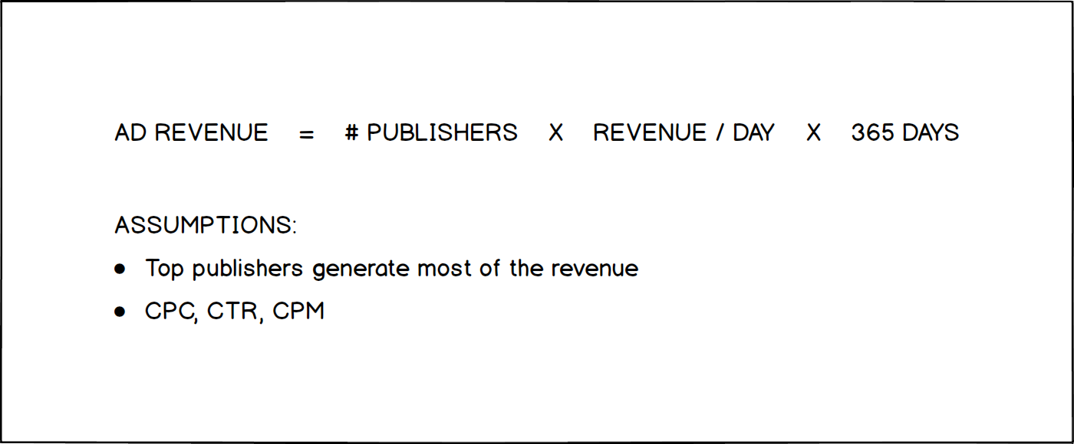

* Breaks down the estimate into smaller components: number of publishers, revenue per day per publisher, and number of days (365 for one year)
* Many publishers use Google AdSense to sell ad space on their websites and make yearly revenue from these ads. So, we will estimate the total ad revenue in one year.

**⇒ Ad revenue = # of publishers x daily revenue per publisher x 365 days**

### **Establishing assumptions -**

* Based on general knowledge of digital publishers, we know that the top 100 online publishers range from the most popular, like ***The New York Times*** to niche publishers like ***Popular Mechanics***.
* ***The New York Times*** has around 10M subscribers, and we assume most are daily readers. In contrast, a publisher like ***Popular Mechanics*** has about 10,000 subscribers that read it once a month.
* We can list at most 20 online publishers like ***The New York Times***, ***Huffington Post***, ***CNN***, and others. And like ***The New York Times***, these publishers draw daily subscribers in the millions, while niche publishers draw subscribers in the thousands that read them monthly.
* So, we can apply the **20/80 rule** here, whereby 20% of the top publishers are likely generating 80% of the AdSense revenue.

**Drawing an estimation tree -**

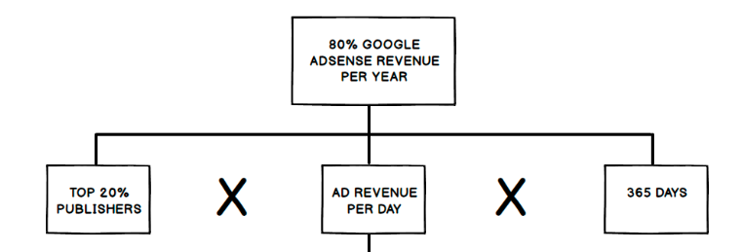

* Using the 20/80 rule, the estimation is for 80% of Google AdSense revenue generated by the top 20% of publishers (the root component).
* We will multiply 20, which represents the top 20% of the top 100 publishers, times the *average revenue they generate in a day*, times 365 days (first level of branches)

**⇒** **20 x average revenue per dayx 365 days**

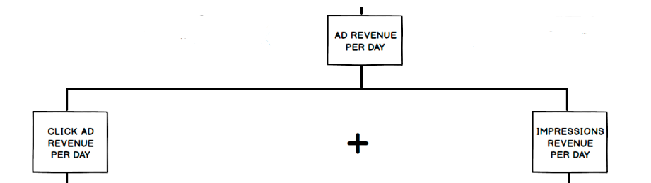

* We decompose ***ad revenue for a day*** into *payment from click ads* and *impression ads*, which are the main ad types offered by Google AdSense (second level of branches).

**⇒** **Ad revenue/day = click ads revenue/day + impressions revenue/day**

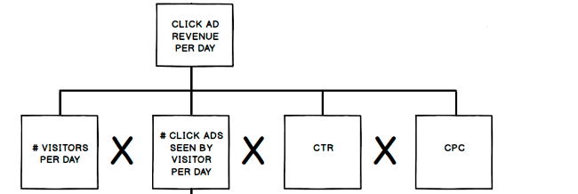

* To calculate the ***ad revenue from click ads for a day***, we will multiply the *number of visitors per day*, times the *number of click ads seen by a visitor*, times the percentage of those ads that the user clicks on, which is the click-through-rate *(CTR)*, times the cost-per-click *(CPC)* (third level of branches).

**⇒Ad revenue click ads/day = # of visitors x # of click ads seen x % of ads clicked**

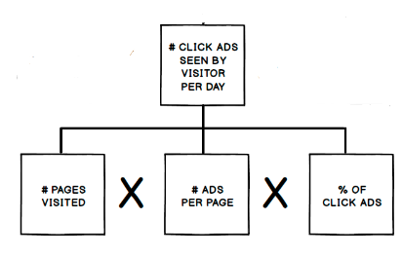

* To calculate the ***number of click ads seen by a visitor in 1 day***, we will calculate the *number of pages visited in a day* times the *number of ads per page* times the *percentage of those ads that are click-ads* (fourth level of branches).

**⇒ # of click ads seen by visitor/day = # of pages visited x # of ads/page x % of click ads**

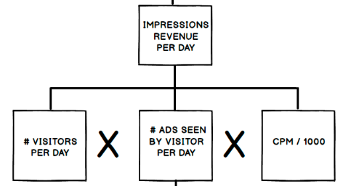

* To calculate the ***ad revenue from impression ads for a day***, we will multiply the *number of visitors per day*, times the *number of impression ads they see per day*, times the *cost per impression*, which is equal to the cost per thousand impressions divided by 1000 (CPM/1000).

**⇒ impressions revenue/day = # of visitors/day x # of ads seen by visitor/day x CPM/1000**

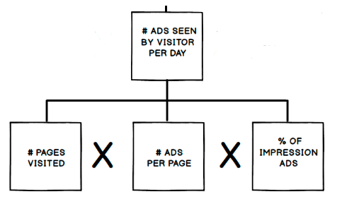

* To calculate the ***number of ads seen by a visitor in one day***, similar to the calculation with click ads, we will multiply the *number of pages a person visits per day* times the *number of ads per page* times the *percentage of those ads that are impression ads*.

**⇒** **# ads seen by visitor/day = # pages visited x # ads/page x % of impression ads**

Finally, our tree for estimation is complete.

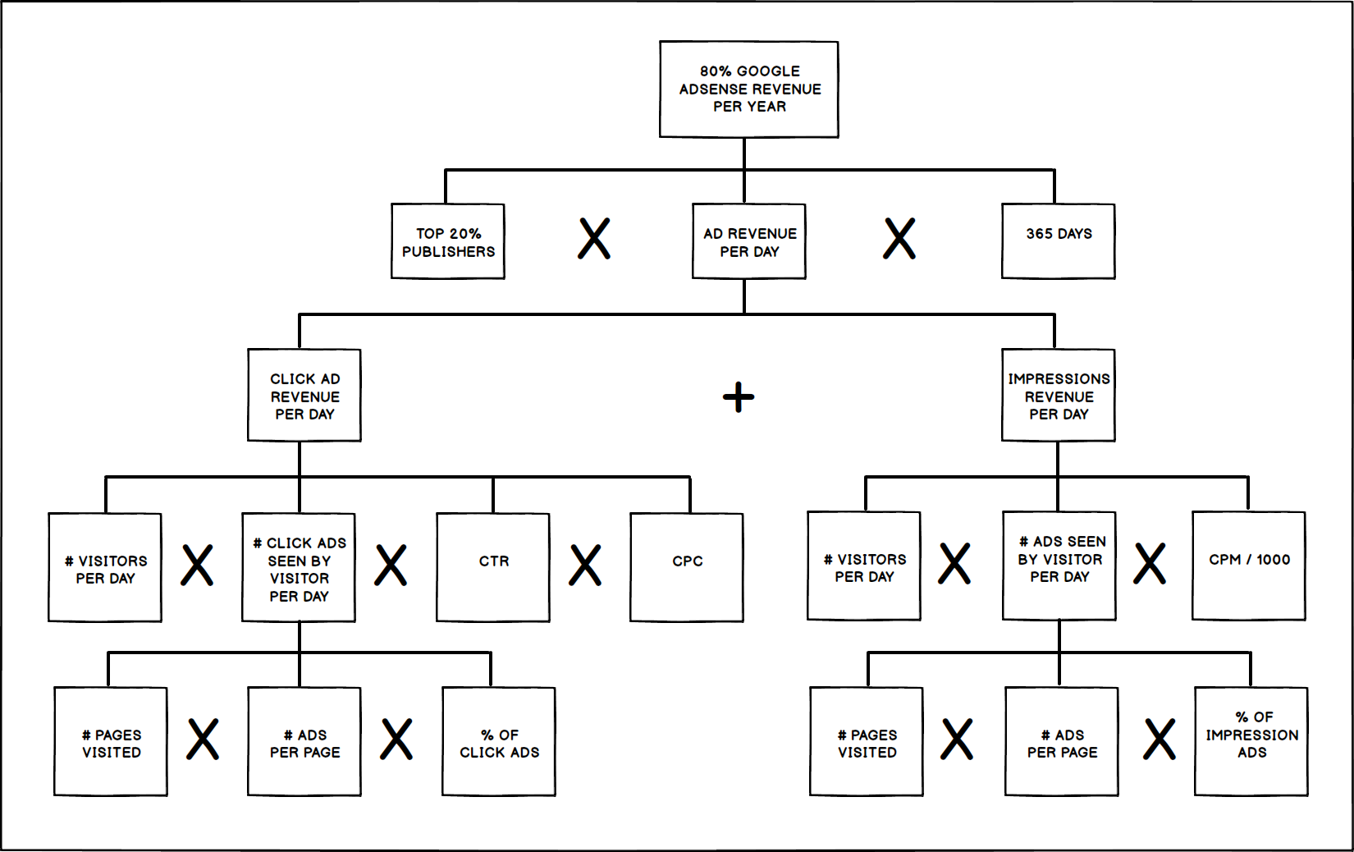

### **Calculating from the bottom-up -**

*Last Branch, Left Side*

* Starting at the bottom left of the estimation tree, I will begin by estimating the *number of pages visited per day* by a reader. Since I subscribe to *The New York Times*, I am going to use myself as your average reader for this estimation.
* I read *The New York Times* daily, usually in the mornings for about 30 minutes and during breaks throughout the day. On average, I read about ten news articles or pages a day. So, I will use **10** for the *number of pages visited per day*.

*(The interviewee used a typical scenario that the interviewer is likely familiar with to explain the assumptions. Next, the interviewee writes down the estimated numbers at the top left corner of the component. )*

* Now, I figure I see at least five ads per page. So, I will put down **5** as the *number of ads per page*. And, I am going to assume that on average 50% of the ads I see are clickable and 50% are impression ads. It is the best guess given that marketers frequently use both ad types. So, I will put down **0.5** or 50% as the *percentage of click ads*. Okay. Now, I can multiply these numbers to obtain the number of *click ads seen by a visitor in one day*: 10 x 5 x 0.5 equals **25**.

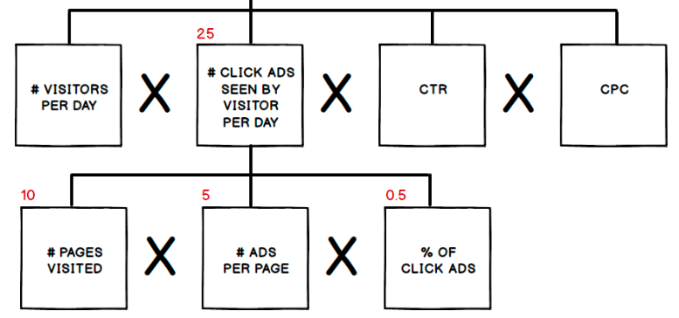

*Third Level Branch, Left Side*

* Of the top 20 publishers, *The New York Times* is one of the most popular publishers in the United States and has about 10M subscribers. So, I will consider this the max range for subscribers. The rest of the top 20 publications will also have subscribers in the millions but less than *The New York Times*. So, let’s say the range of subscribers is between 1 and 10 million. Given no other data point to go by, I am going to take the average, 5M, as the average number of subscribers of these publishers. Since these subscribers are likely to visit their subscriptions daily, I will assume that this is also the number of *visitors per day*.

*(The interviewee writes down* ***5M*** *at the top left corner of the* ***visitors per day*** *component.)*

* Moving on to *CTR*. I will assume an average rate of 0.5% and for *CPC* an average rate of $0.5. These are two common averages for digital display ads. So now, we can multiply the *number of visitors per day* times the 25 *click ads seen by a visitor per day* times the *CTR* times the *CPC* to calculate the *click ad revenue per day*, 5M X 25 X 0.5% X $0.5, which is **$0.3M** per day.

*(The interviewee writes down* ***$0.3M*** *on the left top corner of the* ***click ad revenue per day*** *component.)*

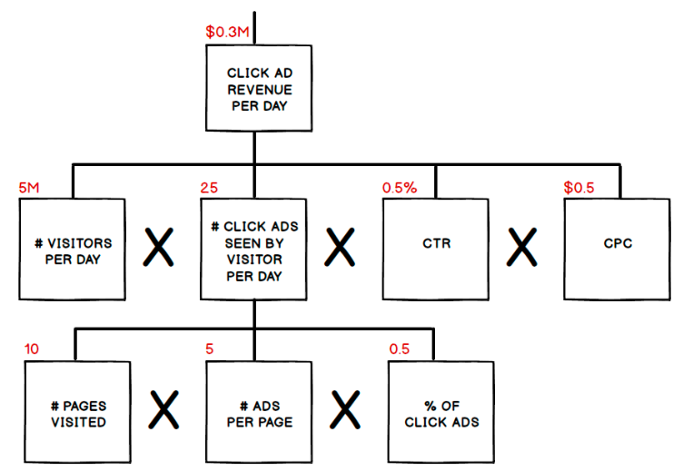

*Last Branch, Fourth Level, Right Side*

* Now, I am going to move to the right side of the estimation tree and calculate impression ads revenue per day. Similar to click ads, I will start at the bottom of the tree. In this branch, all the estimates for the components are the same as the ones for click ads because the number of pages visited by a reader per day is the same regardless of what kind of ads are on the page. The same goes for the number of ads per page. And, I assumed that the other 50% of ads are impression ads. So, the number of ads seen by a visitor per day is **25**.

*(The interviewee writes down* ***25*** *on the top left corner of* ***ads seen by a visitor per day*** *component.)*

*Third Level Branch, Right Side*

* Now, let’s move up one branch. The number of visitors per day is the same as in click ads, **5M**. For the number of ads seen by a visitor, we calculate it to be **25**. And, based on my knowledge of the average CPM for display ads, my estimate is **$1**. So, to derive revenue for impressions per day, I will multiply these three components, 5M visitors/day X 25 impression ads seen X $0.001 per impression. This is equal to about **$0.13M**

*(The interviewee writes down* ***$0.13M*** *on the top left corner of the* ***impressions revenue per day*** *component)*

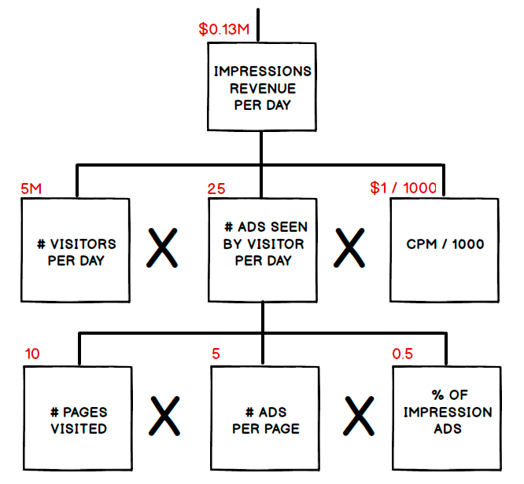

*Second Level Branches*

* Add $0.3M from click ad revenue per day and $0.13M from impressions revenue per day to calculate ad revenue per day. So, $0.3M + $0.13M adds up to$0.4M for ad revenue per day.

*(The interviewee writes* ***$0.4M*** *at the top left corner of the* ***ad revenue per day*** *component.)*

* We now have all the numbers to estimate 80% of Google AdSense revenue per year. So, 20% of the top 100 publishers is 20, times $0.4M of ad revenue per publisher per year, times 365 days. The calculation results in $2.9 billion, which means that the total Google AdSense revenue in a year is $2.9 billion / 80% which is about $3.6 billion.

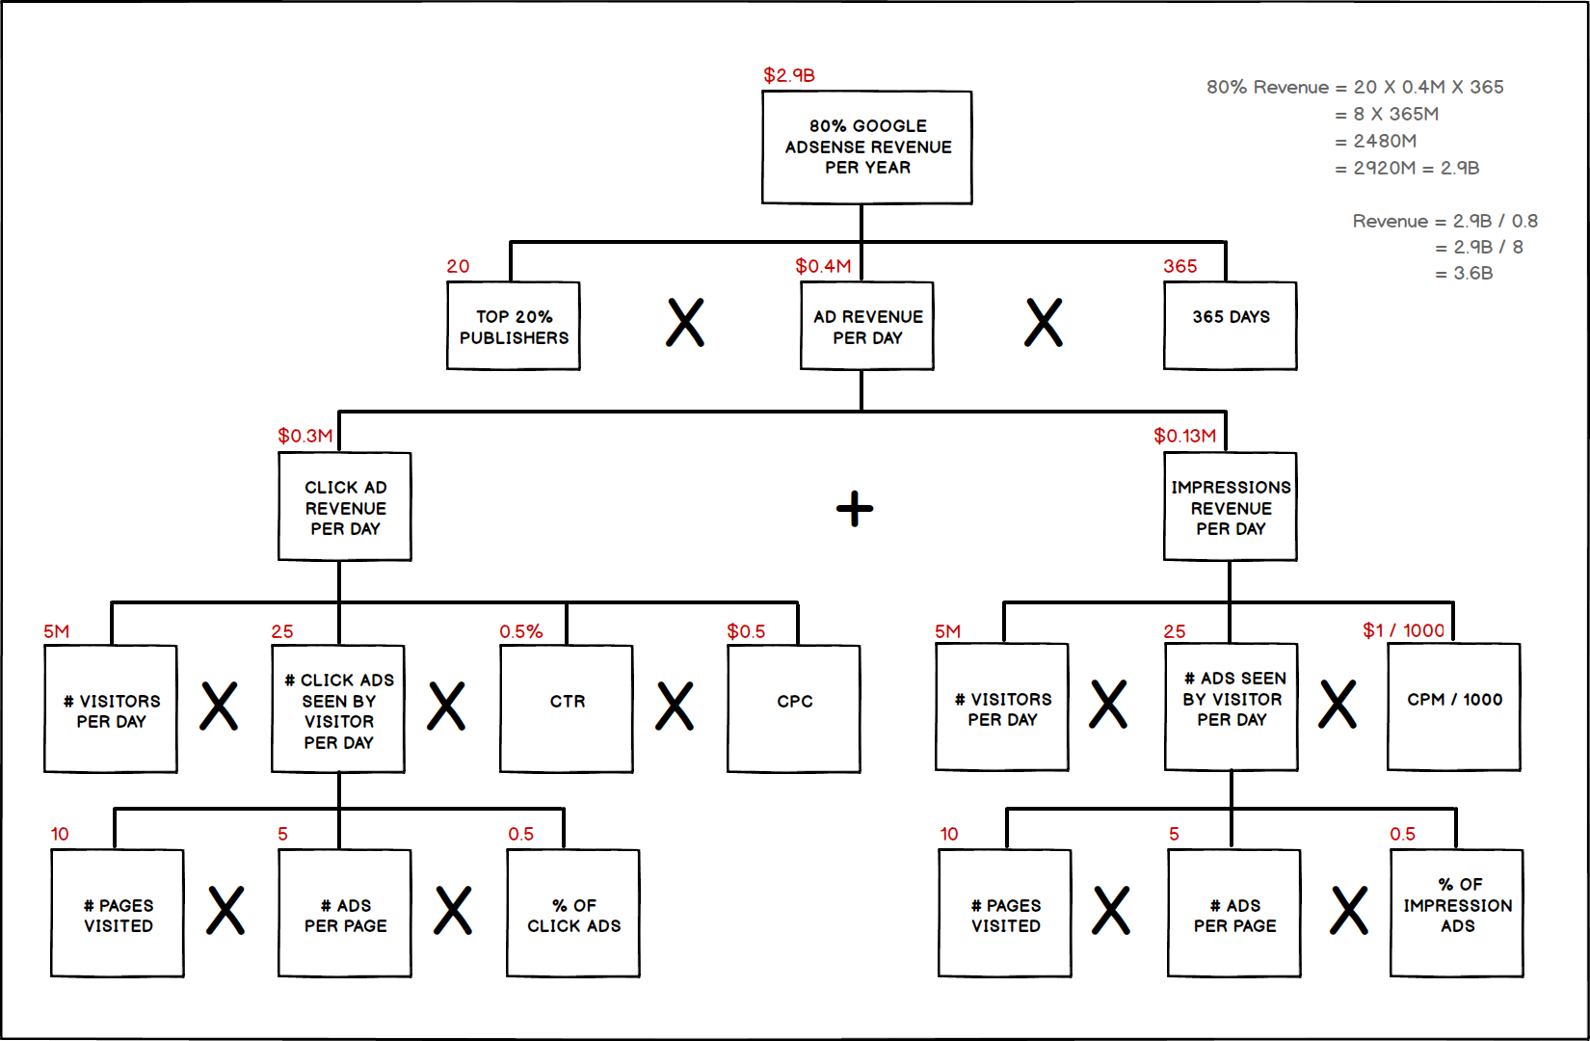

### **Doing a sanity check -**

**Ques. So how do you feel about your estimate? Do you think it is in the ballpark?**

**Actual figure**: From the reading of Alphabet’s last 10K Annual Report, the income from Google Network Member properties is about $17B, so you are off by a factor of about 4.

**Ques. How can you explain that?**

**Ans:** The assumption that only subscribers are daily readers was too conservative. In fact, the majority of people that visit these publishers are probably not subscribers. They are most likely visitors that do not want to pay for subscriptions, yet they want to read these publishers’ content. So, guessing that the ratio between non-subscribers to subscribers that visit these publishers is probably **4:1**, and this explains the discrepancy.

**Instead of 5M visitors per day, I would change it to 5M x 4 or 20M. With this change, my results would have been about $16B, which is not too far off from the $17B in the 10K.**